Table of Contents

Table of contents 1
Lore 3
Game Overview 3
Setup 3
Hero Turn 3
How to Win 4
Variant Rules 4
Mirror pick instead of draft 4
Beginner Chess player 4
Archive final form 4
Setup 4
Hero Sheet 5
General Rules 6
Modes of Play 6
Draft 6
Mirror 6
Turn Order 7
Game Board 7
Battlefield 7
Outskirts 7
Taverns 7
Graveyard 8
Units 8
Main Units 8
Auxiliary Units 8
General Unit Rules add starting square no create 8
King ♚ 9
Queen♛ 9
Rook♜ 9
Bishop♝ 9
Knight♞ 9
Pawn♟ 10
Special Path Types 10
Buffalo / Failed Clone 10
Carnivorous Monkey - 10
enemies must be destroyed 10
Elite Squad of Veterans 10
Legendary Ancient 10
Royalty 10
King’s Powers ♚ 10
Queen ♛ 11
Interactions 11
Adjacent 11
Destroy 11
Battle 11
Create 11
Modify 11
Mark 11
Friendly/Enemy 12
Threaten 12
Protected 12
Check 12
Checkmate 12
Ram 12
Push 13
Castling 13
Promote 13
Tokens 13
Ability tokens 13
Aura tokens 13
Other tokens 13
Peace Treaty / Declaration of War 13
Turn Order 14
Revenge 14
Hazardous Terrain 14
Active Hero 14
Achievement 14
Banishment 14
Destiny 14
Auxiliary Units 14
Destiny (D) 14
Destiny Well 14
Common Destiny Pool 15
Hero Destiny Pool 15
Resilient Destiny 15
Hero Destiny Generation 15
Hero Rules 15
Hero Turn 15
Before Turn 16
Beginning of Turn 16
Before Move 16
Move 16
Before Lead 16
Lead 16
After Lead 17
End of turn 17
Health 17
Health Bar 18
Wounds & Healing 18
Bloodied 18
Unconscious 18
Movement & Range 18
Abilities 19
General hero abilities 19
Epic Heroes 20
Achievements & Legendary Powers 20
Completing Achievements 20
Achievements 21
Legendary Powers 21
6- Hero Unit 21
7 - King’s Forces 22
8-Advanced Warfare (ROOK) 22
9 - Far Reach 22
10- Swift Change 22
11-Final Form 22
Ending the Game 22
Game Components 23
Important Reminders 24
Rules you should not forget! 24
FAQ 24
Index 25
Symbol legend 25
RULE FIXING BALANCE NEŠTO IDEJE 26

Lore
Kingdom of Rošada.

Game Overview
In this 2-4 player team game, players control Epic Heroes whom their King has called upon to lead armies and win the centuries-old war.

Setup
After setting up the play area and forming two teams, each side selects two heroes and then takes turns controlling their units. Chess pieces are referred to as 'units' because they symbolize the armies on the battlefield. Each player, in turn, moves their hero, then leads a unit and uses any desired abilities.

Hero Turn
Heroes first move up to their Movement value and then they must attempt to Lead a Unit (execute a chess move) by rolling the die, the result of which can be affected by various abilities. If the Lead is successful, the unit remains in the square it was Led to. If it leads to a battle, then the enemy unit in that square is Destroyed (“capturing” a piece, in chess terms).
A hero's turn is segmented into Phases and each hero has a unique set of abilities that they may use during their turn. Each ability can be used only once per turn and has a predefined phase in which it can be used. To use an ability, the hero (you), pays the cost in Destiny and then follows the rule set in that ability. Abilities ingeniously 'break' traditional chess rules, offering a unique gaming experience. These abilities allow manipulation of units by creating, modifying, or destroying them, and by making Leads either more or less challenging. They can control and alter the battlefield (chess board), affect other heroes, and even wound them to weaken them or knock them unconscious for a turn.

How to Win
Gameplay continues in turn order from hero to hero until one side either checkmates the enemy or captures the enemy king by destroying him in battle. A checkmate occurs as in traditional chess, but destroying the king in battle is challenging because the king is immune to all abilities. (see Ending the Game pg**)
Enjoy

Variant Rules

Mirror pick instead of draft

Beginner Chess player
Check X amount of times

Archive final form
Archive 11 achievements 1st

Setup
Picture of units and heroes starting squares with names of regions of the board
- Picture of setup board

To play the game, you first need to set up the play area.
- Set the game board and place the Main Units on their starting squares.
- Set the sideboard with a Graveyard and a Destiny Well. Place 16 Destiny crystals in/on the Destiny Well. Leave the other crystals in the box for now - they will come into play at some point later.
- Place an Achievement Tracker, Common Destiny Pool and quick rules reference sheet/s on each side.
- Empty the team bags and organise their contents for easier access during play
- Place the Peace Treaty token on the game board

Then, split into two teams and choose game mode. The mode affects both the Starting and then Epic Hero selection later in the game. Determine which team will play on the Light side and begin selecting your starting heroes according to the game mode rules.
In Draft mode, the Light side selects their first starting hero. Then the Dark side selects both of their starting heroes, followed by the Light side selecting their last starting hero.
In Mirror mode, the Light side selects the first starting hero for both sides, then the Dark side selects the second starting hero for both sides.

After the heroes have been chosen, put your Starting Hero sheet in front of you. Put a health bar, whose red area matches your hero’s maximum health, right above the Hero Sheet. Place a health indicator on the number matching your hero’s maximum health. Set a Hero Destiny Pool next to your Hero Sheet and put 3 Destiny crystals on it.

The light side then decides which of their two heroes will play first and places their Turn Order tokens accordingly, on their hero sheets. After that, the dark side decides their Turn Order. The players will take their turns in turn order, from 1 to 4.

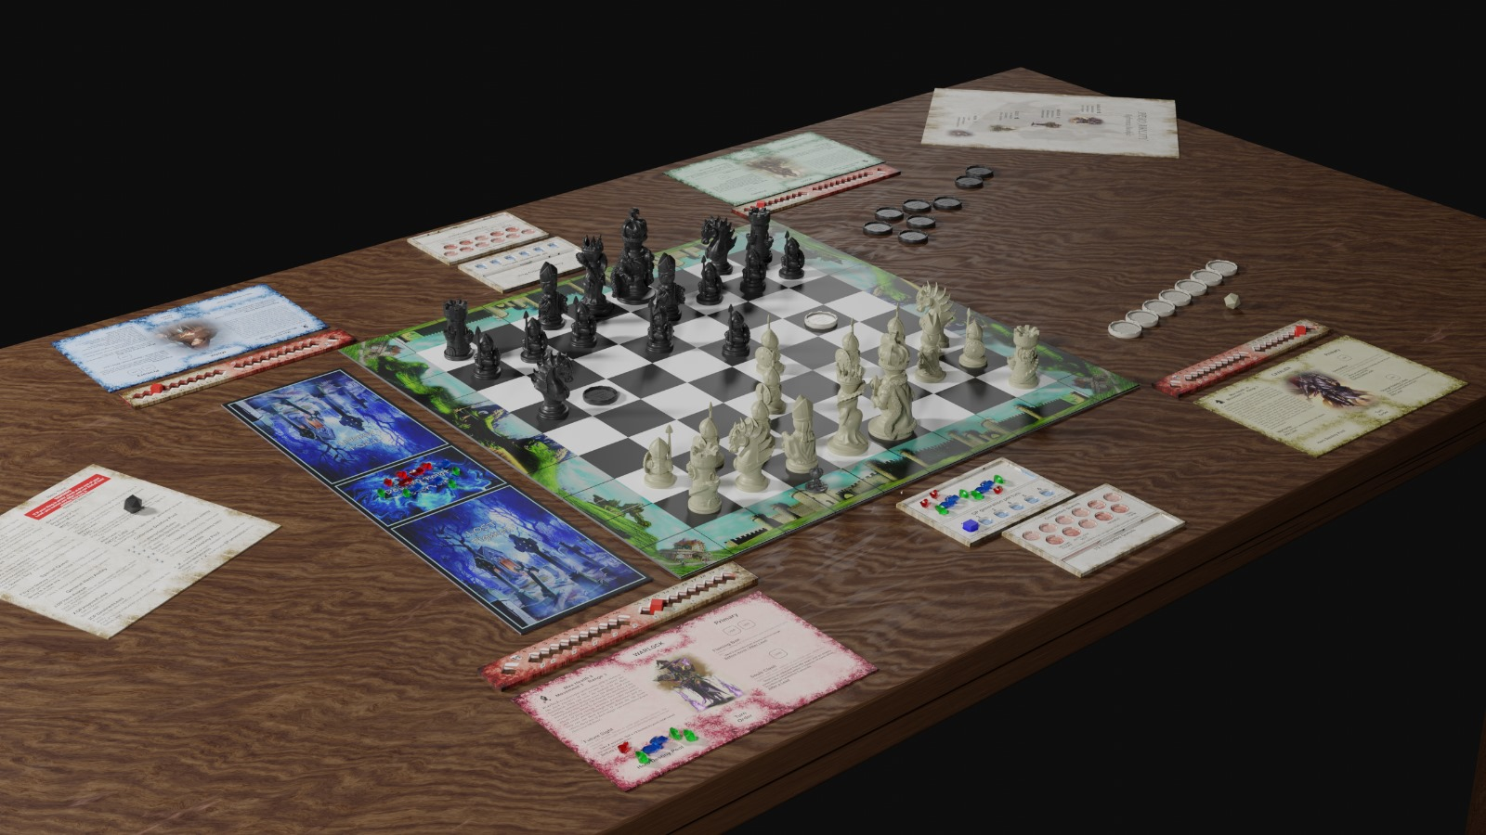
DO NOT FORGET TO MENTION: Pick Heroes per Draft/Mirror rules NEŠTO U SMISLU DA POGLEDAJU PRAVILA ZA DRAFT/MIRROR

Lista komponenti za pokazat sa strelicama crticama na slici:

- Destiny Well - Game starts with a pool of 16 Destiny Points.

Hero Sheet
Information needed to use your hero during the game can be found on your hero sheet.
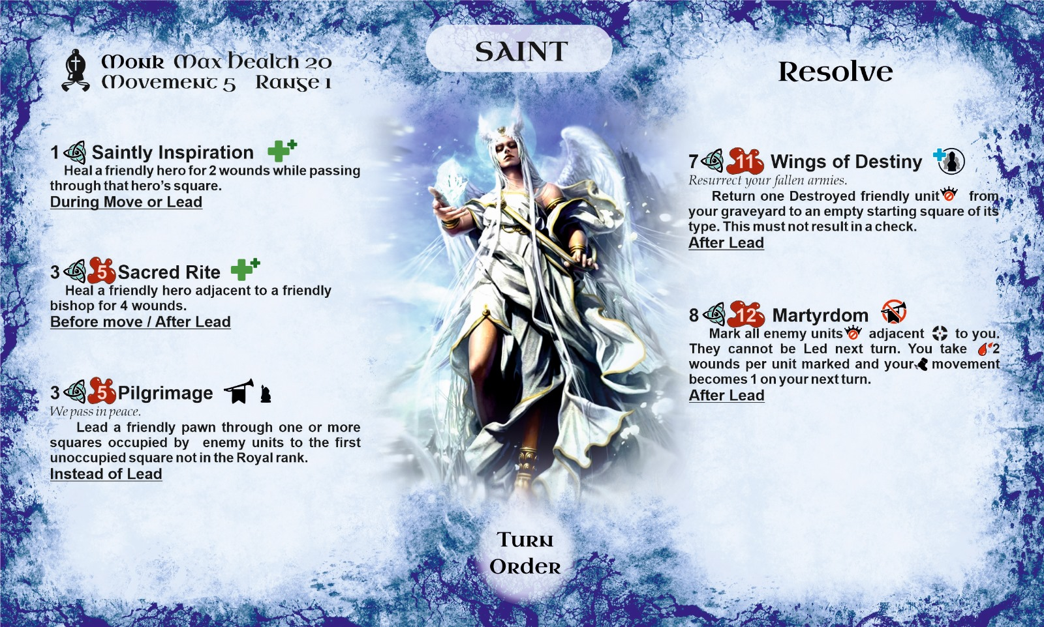

General Rules

Modes of Play
There are two modes of gameplay that determine the hero selection.

Draft
In draft mode every player chooses a different starting Hero

- Choose which team plays with the light-colored units.
- The Light side selects the first starting hero.
- The Dark side selects both of their starting heroes.
- The Light side selects the last starting hero.
- The Light side determines their turn order.
- The Dark side determines their turn order.
- When the initial 16 Destiny from the Destiny Well is depleted, follow “Epic Heroes” rules for draft mode page **

Mirror
In mirror mode both sides play the same two starting Heroes and Epic Destinies.

- Choose which team plays with the light-colored units.
- The Light side selects the first starting hero.
- The Dark side selects the second starting hero.
- The Light side determines their turn order.
- The Dark side determines their turn order.
- When the initial 16 Destiny from the Destiny Well is depleted, follow “Epic Heroes” rules for mirror mode page **
Example: Scouts on both sides are now Royal Assassins and Cavaliers on both sides are now Dragon Riders.
Note: “The Hero that depleted the Destiny Well chooses first and takes the Manifest Epic Destiny achievement token”

Turn Order
A sequence of hero turns which is determined by the number on the Turn Order token assigned to each hero. The light side is always first and third. The dark side is always second and fourth. Starting with the light side, both sides determine their heroes' turn order after all the heroes have been chosen.

Game Board
The game board consists of the following areas:
[nice pic]

Battlefield
An 8x8 grid of alternating dark and light squares.
- Quadrants are a 4x4 square area in each corner of the battlefield.
- Ranks are rows that go from side to side across the game board and are referred to by numbers
  - The rank in which royalty begins the game is called the Royal Rank
- Files are columns that go up and down across the game board and are referred to by letters
- Diagonals are a straight line of squares of the same color.
- Occupied squares are squares that contain a unit.
- Empty squares are squares that do not contain any units, heroes or tokens.

Outskirts
The squares surrounding the Battlefield.
- King’s Court is the row of eight squares between the taverns which contain the Hero’s starting squares. Each Hero’s starting square is the King’s Court square directly behind the starting square of a friendly Bishop.
- Wilderness is the column of eight squares between the taverns.
- Taverns are the four corner squares of the board.

Taverns
Taverns are one of the ways to restore your health when you are wounded.

- Taverns are located in the corner squares of the board.
  - There are 2 types of taverns: friendly and enemy.
  - Friendly Taverns are located on your side of the board.
  - Enemy Taverns are located on the opposite side of the board.
- Your Movement for that turn is reduced by 1 if you are in a Tavern at Beginning of Turn.
- Tavern menu
  - Drink: Costs 1 Destiny and Heals you 1 wound
  - Meal: Costs 2 Destiny and Heals you 3 wounds
- If you are in the friendly Tavern at the End of Turn, get a free Meal.
- During your turn, while you are in a tavern at the start of your turn, or when you pause your Move in a tavern, you may buy Drinks and Meals. After buying during your Move, continue moving with your leftover Movement. Once you leave a tavern, you cannot buy there any more that turn.

Graveyard
The graveyard is a separate board where Destroyed Main Units are placed and it contains the Destiny Well.

Units
Units represent armies that are Led by heroes throughout the fields of battle.

Main Units
    - These are the 16 standard units per side, which are placed on the board during setup.
      - King, Queen, 2 Rooks, 2 Bishops, 2 Knights, 8 Pawns
    - Promoted units are considered Main units.
    - Modified Main units are still considered Main units.
    - Destroyed Main Units are always placed in a Graveyard

Auxiliary Units
    - These are Units that are placed on the board during play.
    - Standard Auxiliary unit types are:
      - Queens, Rooks, Bishops, Knights, Pawns
    - Special Auxiliary unit types are:
      - Buffalo, Failed Clone, Carnivorous Monkey, Elite Squad of Veterans, Legendary Ancient
- Auxiliary pawns cannot be Promoted.
- When you have one or more auxiliary pawns in enemy royal rank your Hero Destiny Generation increases by 1 while they are there.

Hero Units
See Hero Units See pg..

General Unit Rules add starting square no create
- A unit’s starting square of its type is considered to be one of the squares on that color’s side of the board in which that type of unit starts the game.
- The square a Unit is in is considered occupied.
- Units of opposing colors may not occupy the same square.
- The Path of a unit defines how it can be Led.
  - Each unit type has a specific path.
  - The path of the Unit begins with its current square, includes all the squares it passes through and ends with the last square.
  - The unit interacts with all squares in its path and cannot interact with squares occupied by friendly units.
  - If a path interacts with an enemy unit, the Led unit must stop in the enemy unit’s square.

Path Types

King ♚
  - One square in any direction.
  - Castling

Queen♛
  - Any number of squares along its rank, file or diagonal.

Rook♜
  - Any number of squares along its rank or file.
  - 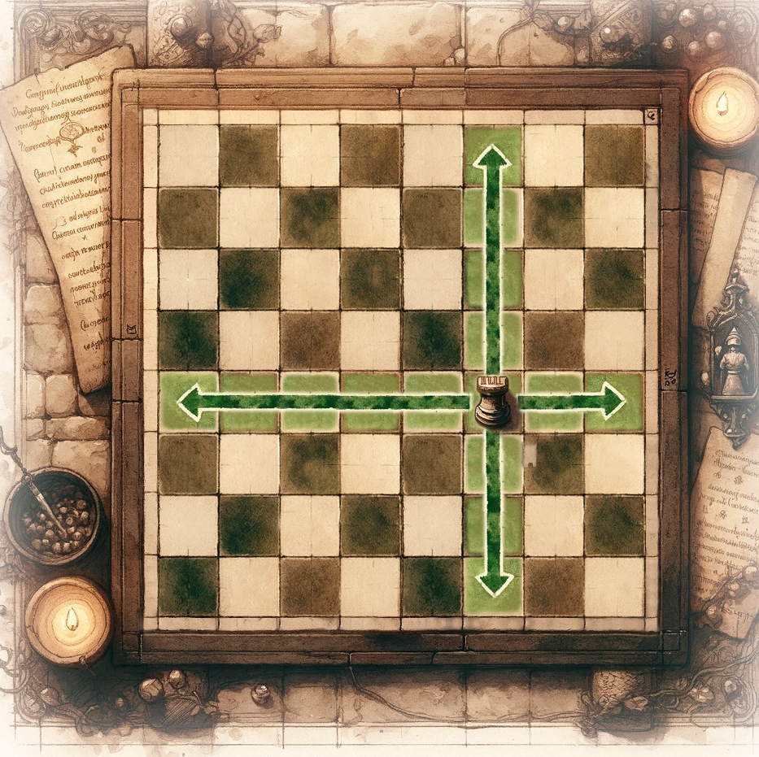

Bishop♝
  - Any number of squares along its diagonal.
  - 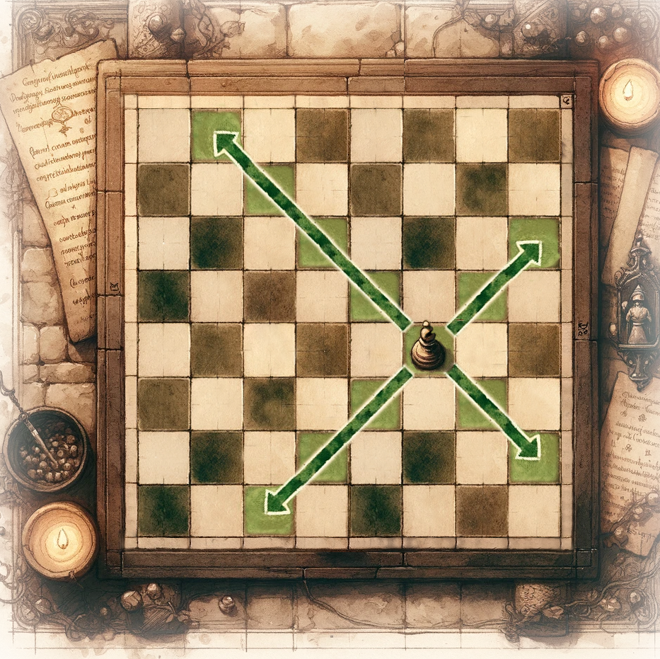

Knight♞
  - 2 squares in its rank or file then turns 90 degrees and moves 1 square. It does not interact with all the squares in its path, it only interacts with its starting and ending squares.
  - 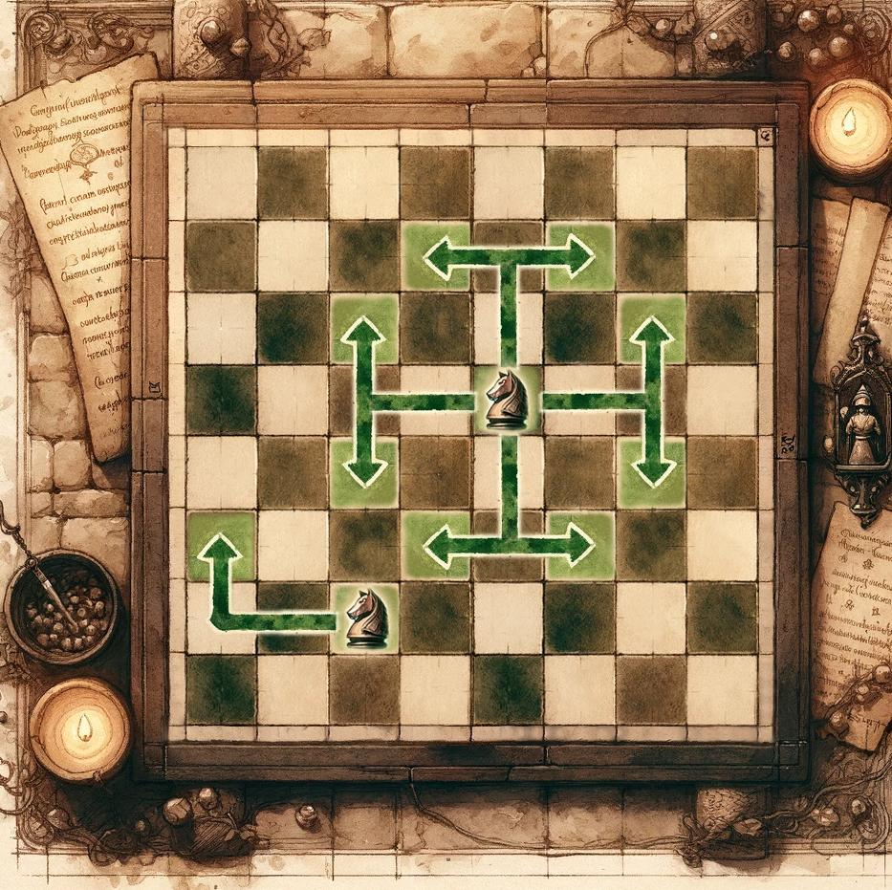

Pawn♟
  - One square forward along its file into an unoccupied square.
  - One square forward on its diagonal into Battle.
  - Two squares forward without battling if it is on its starting square.
  - En Passant
This is a Lead with a pawn in which you initiate Battle with an enemy pawn in a square it just passed through. That enemy pawn has to have been Led 2 squares from a starting square of its type on the previous turn and must have ended in a square on the same rank, adjacent to one of your pawns. You may then Lead your pawn into Battle it to the square directly behind that pawn.
  - Promote (see Promote pg**)

Special Path Types

Buffalo / Failed Clone
  - One square in any direction without initiating battle.

Carnivorous Monkey -

enemies must be destroyed
  - d2 squares along its rank, file or diagonal to an unoccupied square but only interacts with its starting and ending squares.
  - 2 squares along its rank, file or diagonal to an unoccupied square. It initiates Battle with units in the first square and interacts with all squares.

Elite Squad of Veterans
  - One square in its rank and file without initiating Battle.
  - One square on its diagonal if initiating Battle.

Legendary Ancient
  - One square in any direction

Royalty
The King and the Queen are considered Royalty.
 This symbol in abilities means that abilities won’t affect Royalty

King’s Powers ♚

- King’s Supremacy - The King and the square occupied by it are immune to all Hero abilities and ignore their effects, unless specified otherwise.
- King’s Determination - When Leading a King you do not need to Roll the die.
- King’s Verdict - Remove all tokens from the square which the King interacts with during a Lead.
- King’s Banishment - When a hero gets Rammed by the King, send that hero to their starting square and they get a -1 to Movement on their next turn. Friendly heroes are pushed one square back. Get this fool out of my realm
- King’s Majesty -No unit can share its space with the King. Nothing can be pushed into the King’s square.
- In abilities with this symbol, 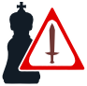Must not check the King does not apply to discovered checks.

Queen ♛
- When your Queen gets Destroyed, your side gains a Revenge token. When making a Lead you may discard this token instead of Rolling the die. Your side can hold a maximum of 2 Revenge tokens at a time.
- The Queen is not affected by elements of an ability that have the symbol

Interactions

Adjacent
- Adjacent squares are the 3x3 area centered on a token, unit or hero.

Destroy
- Units can be Destroyed in Battle or with Abilities.
- Destroyed units are removed from the board.
- Destroyed Main units are placed in the graveyard.

Battle
- A Battle is initiated when a unit is Led into a square occupied by an enemy unit. If that Lead is successful, the enemy unit is Destroyed.
- A unit may not initiate Battle with an enemy unit that cannot be Destroyed.

Create
- You may never create a unit if it would immediately result in a check.

Modify
- Modified units are those whose type is altered.
- You may never modify a unit if it would immediately result in a check.
- You can never modify an enemy unit in a starting square of its type.
- The original unit and its modification are considered the same unit. If the modified unit is Destroyed, then the original unit is Destroyed.
- If the modification ends, the original unit is swapped back.

Mark
- A mark is a token used to indicate that a unit or a hero is affected by an ability. The mark’s duration and effect are described in the ability used.
- As long as a hero or a unit is marked, they are affected by the ability that marked them. The mark is removed when its duration ends.
- A Mark is removed from a Promoted unit if its new type is no longer targetable by the ability that marked it.

Friendly/Enemy
- Friendly units are all units of your side’s color. Friendly heroes are the heroes playing for your side. Any ability that refers to a “friendly hero” also works on the Hero using the ability, unless specified otherwise.
- Enemy units are the units of the opposing side’s color. Enemy heroes are the heroes playing for the opposing side.

Threaten

- A unit that is eligible to be Lead is considered to Threaten squares it can interact with in its path, including the squares occupied by the first friendly units. A unit which cannot be Led because the Lead would leave its King in Check is still considered eligible to be Led.
- A King may not be Led into a threatened square.

Protected
- A friendly unit is protected if another friendly unit Threatens its square.

Check
- A check occurs when a unit Threatens the King.
- A unit cannot be Led if that Lead would leave its King in Check.
- If your King is in check you get a +4 bonus to Lead.
- If your King is in check at the end of your Lead, you cannot use After Lead nor End of Turn abilities that turn.
- A discovered check is when a unit that hasn’t been Led checks the King.

Checkmate
- A Checkmate is a state of the board in which a King is in check and neither the King nor any eligible units on the board can remove all the threats the King is under.
  - Eligible units are only those that are currently on the battlefield and could be Led without the use of abilities, even if not in a hero's range. Abilities that are already in effect are considered for eligibility.
- If a King is in checkmate in the Before Turn phase of a player’s turn, the game ends. The side that Checkmated the enemy King wins the game.
(see Ending the Game on pg**)

Ram
- Enemy heroes are considered Rammed if the path of your Lead interacts with their square.
- A Rammed hero is pushed along the path of that unit, interacting with those squares, and lands in the next square in the direction of that path, taking 3 wounds. That hero may not Lead themself into Battle with the unit which Rammed them on the last turn. (daj primjer sa slikom, kad konj ramma) (Prijedlog-A hero unit mayy not be lead into battle with a unit that Rammed that hero last turn.)
- If that square is occupied by a King, the Rammed hero is sent to their starting square.
- If several heroes share a square that the path interacts with, all enemy heroes in that square are Rammed. The path also interacts with squares occupied by friendly heroes, but friendly heroes are never Rammed.
- A Knight only interacts with its starting and ending squares, so it Rams the enemy heroes in its ending square. They are pushed one square back: one more square in the direction of the Knight’s last 1-square move, taking 3 wounds.
(see Hero Turn pg**)

Push
- When a unit or a hero gets pushed, they’re moved from one square to another. The exact way is described in its source.
- If a Hero is Pushed outside of the board or into the King, they are instead sent to their starting square.
- An ability that pushes a unit may not be used if it would push that unit off the battlefield.

Castling
- Castling is a Lead with the king.
- Lead the king 2 squares toward a friendly rook in the Royal rank and then place that rook in the square the king just crossed. The rook does not interact with any squares during this Lead.
- This Lead is not allowed if either the king or rook have previously been Led, if the squares the king would interact with are threatened, or if any unit occupies the squares between the king and rook.

Promote
- When an unmodified Main Pawn enters a square in the enemy's royal rank, it is immediately replaced with any standard unit type except the King and the Pawn. This is a Promotion and the replacement is considered a Main unit.
- If a pawn of your color is Promoted during your turn, you decide which unit to promote it to.
- If a pawn of your color is Promoted during the enemy’s turn, the next hero on your side in the turn order decides which unit to promote it to.
- Auxiliary pawns cannot be promoted (see Auxiliary units pg**)

Tokens

Ability tokens
These tokens are used to identify effects of abilities. Some abilities have their own special tokens which are described in the ability. While these tokens are in play, their corresponding ability effects are active.

Aura tokens
These tokens are placed by a Hero to indicate they possess an aura. Each aura is described in Hero ability

Other tokens

Peace Treaty / Declaration of War
This token is placed on the board with the Peace side up during setup.
- While the Peace side is up, Leads do not require a roll.
- Flip the token to the War side if:
  - either side uses an ability, affecting a unit.
  - either side gains Destiny.
- While the War side is up, all Heroes get a +2 bonus to Lead.
- The token is removed from play when “Manifest Epic Destiny” has been achieved.
(see Special Achievements pg **)

Turn Order
The number on this token indicates the hero’s placement in the sequence of play.

Revenge
Every time a Queen of your color gets destroyed, your side gains this token. You can discard it to automatically succeed on a Lead instead of rolling the die. Your side can hold a maximum of 2 Revenge tokens at a time.

Hazardous Terrain
Squares that contain this token are considered occupied by a friendly unit.

Active Hero
This is a token which indicates the Hero whose turn it is currently. (see “Player Turn” pg**)

Achievement
These tokens are used to track your achievement progression. (see pg**)

Destiny
One Destiny token represents five Destiny crystals.

Auxiliary Units
Each side gets a set of tokens which represent auxiliary unit types (see pg**)

Destiny (D)
Destiny is the resource which heroes spend to use their abilities. Heroes may spend destiny from their side’s common pool, from their hero pool, or a combination of both.

Destiny is represented by Destiny crystals. There’s no difference between Destiny crystals of different colors. There's no limit to how much Destiny you can generate from Destiny Well. 5 Destiny crystals can be represented by 1 Destiny token. The amount of Destiny available for use during the game is not limited by the number of Destiny crystals and Destiny tokens contained in the game box.

Destiny Well
Whenever you gain Destiny, you take it from the Destiny Well
- At the beginning of the game, there are 16 Destiny crystals in the Destiny Well.
  - No Destiny spent before the Epic Stage is placed in the Destiny Well.
- When the 16 Destiny crystals are depleted, add all the Destiny crystals not in Hero or Common Pools to the Destiny Well. From here on, all Destiny spent is placed in the Destiny Well.

Common Destiny Pool
You can gain Destiny to the Common Pool in the following ways:
- 2 D when you Check an enemy King. You may benefit from this only once per turn.
- 2 D when you Destroy one or more enemy units in Battle or with an ability.
- 1 D for each friendly unit every time it gets Destroyed.
- 1 D every time you wound an enemy hero.
- 1 D when your Lead fails.

Note: You do not gain any D for destroying friendly units, dealing wounds to friendly heroes, taking wounds from friendly heroes or taking wounds from your own abilities.

Hero Destiny Pool
- At the beginning of the game, there are 3 Destiny crystals in each Hero’s Destiny Pool.
- Gain Resilient Destiny when you get wounded.
- Gain Destiny equal to your Hero Destiny generation at End of Turn.

Resilient Destiny
- Gain Destiny equal to the amount indicated on your health bar when you take wounds from enemy heroes and units.
  - Self-inflicted wounds or those inflicted by a friendly hero do not generate “Resilient Destiny”.
Example: If you are at 8 health and take 5 wounds you gain 2D. You gain 2D not 3D because you gain D when your health indicator reaches or passes the Resilient Destiny points on your health bar, not when it leaves them.

Hero Destiny Generation
- At the start of the Epic Stage, place the Destiny indicator on 1 in the Hero Destiny Generation tracker.
- Whenever you’re missing friendly units of a certain type (♛,♜,♝,♞,♟), your Destiny generation increases by 1.
- Whenever a friendly unit of a missing type (♛,♜,♝,♞,♟) returns to the board, your Destiny generation decreases by 1
- When you have one or more auxiliary pawns in enemy royal rank your Destiny generation increases by 1 while they are there.
Example. You don’t have a Queen and a Knight on the board. Your Destiny generation is on 3. You lose your last Bishop and increase your Destiny generation to 4. You then use the “Knight a Peasant” ability, which changes a pawn into a Knight, and decreases your gen to 3. (pic explain)

Hero Rules
Heroes... Chosen of Destiny.. brave souls, summoned to the eternal battlefield by their monarch.

Hero Turn

Every Hero’s turn consists of a sequence of phases.
- Phases must be resolved in order.
- You may use abilities during the phase defined by the ability.
- In each phase, resolve all effects relevant to that phase.
- If multiple game effects occur during the same phase of a player's turn, that player decides the order in which they resolve.

Phases of hero turn:
Before turn -> Beginning of turn -> Before Move -> Move -> Before Lead -> Lead -> After Lead -> End of Turn.

Before Turn
- You receive the Active Hero token but your turn has not yet begun.
- If a King is under checkmate, the game ends. (chare enemy lines ? dose invurbele prevent checkmate)
- If the initial 16 Destiny was depleted during the last turn the Starting Heroes become Epic Heroes and the Epic Stage has begun.

Beginning of Turn
- You become the Active Hero.
- If you have the Hero Unit power, you can become or stop being a hero unit. (see Legendary Powers pg**)

Before Move

Move
- You may Move through any number of squares up to your Movement. You interact with those squares and they must be sequentially Adjacent to each other.
- You can never voluntarily end your Move in a square occupied by an enemy unit or a King, unless specified otherwise by a hero ability.
- Movement cannot be reduced by more than 2.
- Resolve all effects and abilities that occur during this phase.
(Many pic explainers)

Before Lead

Lead
Choose a unit-> Announce a Square -> Roll the die -> Place the unit
- You may only attempt one Lead per turn, unless otherwise specified by an Ability.
- You must attempt a Lead if possible.
- If attempting a Lead is not possible, you cannot use After Lead nor End of Turn abilities this turn.
- You cannot attempt a Lead that would put your King in check.
- Choose a friendly unit within your range.
- Announce which direction and to which battlefield square that unit will be Led following the path defined for that type of unit.
  - You may not announce a square in which the path of that unit may not legally end.
  - If you announce a square occupied by an enemy unit, that Lead is considered a Battle.
- Roll the die.
  - A Lead requires a roll, unless specified otherwise by an ability or a token.
  - When Leading a King you do not need to Roll the die.
  - Make a roll with a 20-sided die (d20) to determine whether the Lead is successful or not.
  - A successful lead is a total of 6 or higher, after all modifiers have been applied to the number showing on the die.
  - If your King is in check you get a +4 bonus to Lead.
- Place the unit.
  - The path of the Lead begins with the unit’s current square and ends with the announced square.
  - Lead the unit along its path to the announced square.
  - If it is a Battle, all enemy units occupying that square are considered Destroyed.
  - While your Range is 1, you move with the unit, ending this movement adjacent to it.
  - Rammed
    - Enemy heroes are considered Rammed if the path of your Lead passes through their square.
    - A rammed hero is pushed along the path of that unit and lands in the next square in the direction of that path, taking 3 wounds.
    - If that square is occupied by a King the rammed hero is sent to their starting square.
  - If your King is under check at the end of your Lead, you cannot use After Lead nor End of Turn abilities that turn.
- The use of an Instead of Lead ability replaces your standard Lead but is still considered a Lead. You must still comply with all the above rules for Leading, unless otherwise specified by the ability.

After Lead

End of turn
- Gain D equal to your Hero Destiny generation if you’re an Epic Hero
- Give the active hero token to the hero next in turn order.
- You are no longer the Active Hero.
- If you have not used your Hero Unit power and have the Final Form power, you can become or stop being a hero unit. (see Legendary Powers pg**)

Designers’ Note: While a sequence of hero turn phases is strictly defined, some leeway is acceptable, as long as Active Hero token has not been passed and/or no new information has been revealed, such as a failed/successful Lead or any ability with a roll of a die or any enemy ability with a DP cost of 0 or more that activates during your turn.
For example, you move your hero 2 squares and then use a Before Lead ability, only to unit out it’s more advantageous for you to move your hero 3 squares and use said ability. In that and any such or similar case, it’s OK to ask other players to let you change or modify the phases of your turn.

Health
Health represents the number of wounds a hero can take before falling Unconscious.

Health Bar
After your hero has been selected, take the appropriate health bar according to the maximum health written on your hero sheet and place a health indicator on it.
- The health bar shows your current health by the placement of the indicator, your maximum health, and when you gain Resilient Destiny. (see Resilient Destiny pg**)
- The red area on the health bar indicates your Starting Hero’s maximum health and the Bloodied status when you are an Epic Hero.

Wounds & Healing
- Health decreases by the number of wounds taken, down to 0.
  - As your health decreases you gain Resilient Destiny. (see Resilient Destiny pg**)
  - When you are at or below half your maximum health you are Bloodied.
  - When you are at 0 health you are Unconscious.
- Health increases by the number of wounds healed, up to your maximum.
  - Heroes can heal wounds in taverns and with abilities.
(See Taverns on pg **)

Bloodied
- Starting Heroes cannot be Bloodied, only Epic Heroes can be Bloodied.
- Epic Heroes are considered Bloodied when their current health is in the red area of the Health bar.
- The cost of most Hero abilities increases when the Hero is Bloodied. The Bloodied cost is indicated by the red colored number (X) on the right side of 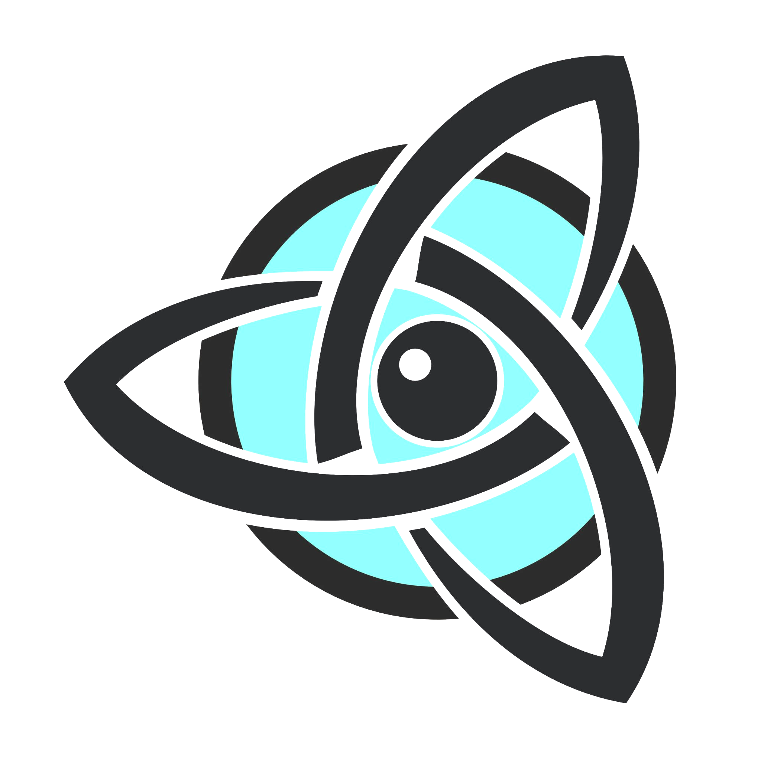.
- Some Hero abilities may have additional and/or alternate effects when the Hero is Bloodied. These changes or alternatives are described by the red text in the ability. (e.g. Mark an enemy unit/any unit, Before move / After Lead)

Note: Starting Heroes cannot be Bloodied. Because of this, Vanquish your Foes can only be achieved in the Starting Stage by bringing an enemy hero to 0 Health (Unconscious)

Unconscious
- When the Hero’s current health reaches 0, they become Unconscious and are immediately returned to a friendly tavern of their choice.
- The Unconscious Hero must skip their next turn and on the subsequent turn, they receive Heroic Recovery.
- At the Beginning of Turn, Heroic Recovery Heals the Unconscious Hero to half health and they are no longer Unconscious.
“Note: heroes with a max health of 20 heal to 10 and heroes with a max 16 heal to 8.”
“Designers note. This is very dangerous, because allowing your opponents to have 2 consecutive Leads can end the game by Battling the King.”

Movement & Range
Movement and Range define the area a hero influences.

Movement is the number of squares a hero can move up to during the Move phase of their turn. The hero interacts with those squares and they must be sequentially adjacent to each other.
You cannot end your move in a square occupied by a King or an enemy unit. Heroes can share a square with other heroes, friendly or enemy.
Movement cannot be reduced by more than 2.

Range is the number of squares away from the hero in which they can initiate Leads. Additionally, some abilities rely on range. Range is counted in any direction, including diagonally.

There are three types of range: Short range, Long range and Hero unit range.
- Short ranged Heroes have a Movement of 5 and a Range of 1. They Lead a unit in range and advance with the unit along its path without interacting with those squares. They then end their advancement in a square of their choice adjacent to that unit, which is not occupied by a King or an enemy unit.
- Long ranged Heroes have a Movement of 3 and a Range of 3. They Lead a unit in range from their current square. They remain in the square they made the Lead from.
- While Heroes are Hero units they skip their Move phase and have a range of 2. They can Lead themselves or by a friendly hero. If they Lead another unit, they remain in the square they made the Lead from regardless of their original type of range.
Note: Skipping your Move phase does not mean you skip your Before Move phase.

Abilities
All Heroes have a unique set of abilities which they use to affect gameplay.
- Heroes can only use the abilities on their sheet and the general Hero abilities.
- An ability is
- Starting Heroes can use each of their abilities only once per turn, but they have a limited number of uses.
  - To use an ability from their hero sheet, Starting Heroes place a Destiny on the Destiny symbol by the ability used and discard it to the Destiny Well when they become Epic.
  - Starting Heroes can use general Hero abilities once per turn and remove spent Destiny from play.
- Epic Heroes can use each of their abilities with a D cost and the general Hero abilities only once per turn and immediately discard spent Destiny into the destiny well.
- Each ability can be used only during a phase specified at the bottom of its description.
- The initial D cost of each ability is located to the left of the D symbol.
- While Bloodied, the initial cost of each ability is located to the right of the D symbol in red.
Some Hero abilities may have additional and/or alternate effects when the Hero is Bloodied. These changes or alternatives are described by the red text in the ability.
- Abilities cannot directly target the King and the King ignores the effects of abilities, unless specified otherwise.
- The use of an Instead of Lead ability replaces your standard Lead but is still considered a Lead.
- If a Hero is pushed into a square occupied by a King or off the board, they are instead placed in their starting square.
Note: In the descriptions of the ability where the word “you” is used, it refers to the hero using the ability.

General hero abilities
- 2 D Hero Retreat
Place your hero into a friendly tavern and gain a free Drink.
End of Turn

- X D Inspired Lead
Gain a +2 bonus to your next Lead for every 1 D spent.
Before Lead

Epic Heroes
Heroes become Epic by choosing between the Fanatic, Resolute or Dominant Destinies.
Prijedlog: Razmislit još jednom da se izbjegne korištenje riječi Destiny i za ability resurs i za levelup heroja. “Epic Heroes” i “Starting Heroes” je vjerojatno sasvim dovoljno, pogotovo šta se igra zove “Rošada: Battle of Heroes”.
Also, dok san prtlja po long rules videoskripti san i nesvjesno pisa “Epic Heroes” i ovog momenta dok pišen ovo mi dodavanje “Destiny”-a na to pari baš nekako konfuzno.

FANATIC: "With unbridled zeal, and unwavering sacrifice, we march towards our ascent."
RESOLUTE: "No shadow too dark, no foe too fierce, my courage stands tall."
DOMINANT: "Under my rule, the realm kneels, by my hand, it rises."

When the initial 16 Destiny from the Destiny Well is depleted during a Hero’s turn, all Destiny not in Hero or Common Pools is added to the Destiny Well immediately and the turn continues normally. On the next Before Turn phase, the Epic Stage of the game commences.

- In the Before Turn phase during which the Epic Stage began, every hero chooses their destiny in turn order.
The same side may not combine Heroes from Fanatic and Dominant Destinies.
Note: “The Hero that depleted the Destiny Well chooses last and takes the Manifest Epic Destiny achievement token.”
- Replace your Starting Hero sheet with your chosen Epic Hero sheet
- If your epic hero doesn't have an ability from your starting hero sheet remove them (Bear trap is an exception).
- Distribute the Destiny in each side’s Common Pool evenly between their two Hero Pools. If the Common Pool contains an odd number of Destiny, leave 1 Destiny in it and distribute the rest as described.
- Short range Hero's maximum and current health increases by 10. Long range Hero's maximum and current health increases by 8.
- Place the Destiny indicators on 1 on Hero Destiny Generation trackers(see “Hero Destiny Generation” pg**)
- Remove the Declaration of War token from the board.
- The Hero’s turn in which the Epic stage began, continues normally.

Achievements & Legendary Powers
Your achievements on the battlefield bring you closer to mastering Legendary Powers.

Completing Achievements

- 10 numbered Achievements can each be completed only once per side
- Tides of Destiny achievement can be completed 5 times per side.
- Each Achievement has its own requirement/s for completion. Some Achievements can be half completed. When you half complete those Achievements, place their tokens in the ½ completed area.
- When your side fully completes an Achievement, place the corresponding Achievement token in the next empty Achievement slot.
- As the Achievement track fills you unlock Legendary Powers.

Achievements
- Bloody the Castle Gates - Destroy an enemy unit in Battle in the enemy’s Royal rank.
- Overwhelm - Ram an enemy hero 2 times or 2 enemy heroes once each.
- Great Incursion - Have 3 friendly, non-hero units within the 4 ranks on the enemy’s side of the battlefield.
- Tactical Genius - Make a discovered check without Destroying a friendly unit with an ability.
- Deploy Troops - Have 3 or fewer friendly pawns on friendly pawn starting squares.
- Royal’s Fury - Destroy 3 units in Battle with Royalty (King and/or Queen). Royal Fury tokens have numbered sides (1,2).
- Decimate - The enemy has 7 Destroyed main units in the graveyard.
- Offense is the Best Defense - Threaten an enemy unit by 3 friendly units.
- Vanquish your Foes - Bring an enemy hero to 0 Health or Bring two different enemy heroes to Bloodied.
- Destined for Greatness - Have 20 or more Destiny crystals on your side at End of Turn.

Tides of Destiny - The initial 16 Destiny in the Destiny Well has been depleted and you gained at least 1 Destiny in your Common Pool during your turn.

Note: Starting Heroes cannot be Bloodied. Because of this, Vanquish your Foes can only be achieved in the Starting Stage by bringing an enemy hero to 0 Health (Unconscious)

Legendary Powers
When you have a set amount of completed Achievements, gain the corresponding powers

6- Hero Unit
As heroes complete achievements, they grow in power and can battle armies on their own.

Heroes gain the power to become a Hero Unit capable of interacting with other Units as a Unit. Your hero may become or stop being a hero unit of the type indicated on your hero sheet.
That hero unit:
- may Lead themselves.
- may Lead other units, with a range of 2. The hero unit remains in the square from which they made the Lead. When you Lead a hero unit, gain a +4 to that Lead.
- may be Led by other friendly heroes
- takes 3 wounds if they get Destroyed in Battle. Then, that hero is placed on their starting square and is no longer a hero unit.
- takes 3 wounds if they are Destroyed by an ability that Destroys Main units. If that ability also deals any additional wounds to that hero, those wounds are ignored. Then, that hero is placed on their starting square and is no longer a hero unit.
- may not lead themself into battle with the unit which Rammed them on the last turn.
That hero may not turn into a unit:
- while in an occupied square.
- if they would check the King from that square
- if they’re not on the battlefield
- If their King is in check and they are in the path of that check. (this must have pic explainer)

7 - King’s Forces
Get a King’s Forces token. You can spend it to create an auxiliary unit of your type in your square if it’s unoccupied using all the rules for turning into a hero unit.
Beginning of turn

8-Advanced Warfare (ROOK)
When becoming a hero unit, they may turn into a rook or the unit type indicated on your hero sheet.

9 - Far Reach
Your Range to Lead while you are a Hero Unit is now 4 instead of 2.

10- Swift Change
You can use a Hero Unit power at the End of Turn

11-Final Form
When becoming a hero unit, they may also turn into both Rook and Bishop/Horsey (unit type indicated on your hero sheet) simultaneously.

Ending the Game
The game ends when:
- There is a Checkmate in the Before Turn phase.
- A King gets Destroyed in Battle.
- A Draw occurs.

- If a King is under checkmate in the Before Turn phase of a player’s turn, the side that Checkmated the enemy King wins the game.
  - A Checkmate is a state of the board in which a King is in check and neither the King nor any eligible units on the board can remove all the threats the King is under. Eligible units are only those that are currently on the battlefield and could be Led without the use of abilities, even if not in a hero's range. Abilities that are already in effect are considered for eligibility.
Note: Since the checkmate occurs in the Before turn phase of a hero’s turn, no hero abilities that can be used in later phases of that hero’s turn can be considered for resolving the check/s.

- When you successfully Lead a friendly unit into Battle with an enemy King. This results in your side winning the game.

- A Draw occurs when:
  - Both kings are in check in the Beginning of Turn and End of Turn phases of your turn the game ends in a draw.
  - The active Hero has no units eligible to be Led during the Lead phase of their turn, even if the range of that Hero is disregarded.
  - One side offers a draw and the other side accepts it.

Game Components
Contents

Boards
1 Game board
1 Unit Graveyard/Destiny Well
2 Destiny tracker
2 Achievement tracker
8 Hero health bars

Cardboard
61 Auxiliary unit tokens
16 Hero Auxiliary Unit indicators
76 Ability effect tokens
11 Aura tokens
12 Hero unit tokens
? Special tokens
8 Heroes standees
30 Achievement tokens
4 Turn order tokens

Plastic/Resin
32 Main units (Chess set adheres to FIDE
Tournament Standards of Chess Equipment)
34 Main unit tiles
8 Hero miniatures
4 Standee bases
4 Hero snap bases
51 Destiny crystals
7 Plastic cubes
2 Dice, 20 sided
16 Auxiliary unit holders

Paper
1 Rule Book 8pg
1 Rule Ref 32pg
1 Hero Guide 32pg
2 Quick reference sheets
32 Hero sheets

Other
2 Team bags
8 Hero specific bag
1 Sticker sheet

Important Reminders

Rules you should not forget!
While following all the rules is crucial, there are some that hold the power to break the balance of the game greatly.

Knowing when you are allowed to, or more precisely not allowed to Create and Modify units is of the utmost importance. Creating a unit or Modifying one that directly threatens the king could bring the game to a quick and abrupt end that has nothing to do with tactical play. See Creating or Modifying Units on page ***.

King never shares a square. King never requires roll for Lead even when castling or when an ability calls for a roll.

FAQ
- Q- A hero gets dropped to zero health and stage 2 begins immediately after that, does that hero lose the next turn or not, because he got some health from the destiny transformation.
A- Yes, they still lose the next turn because the trigger for losing the next turn is dropping to 0 health!

- Q- Can the Airsmith use Zeppelin Pb-82 to turn Smugglers' Grotto into a rook?
A- Yes, the rook is created Adjacent to the Grotto in the same rank.

- Q- How much DP does the Red Carpet generate?
A- 4 DP total for the side that used it, 2DP For destroying units plus 2 for Destroying a unit in Battle. 3DP total for the other side, 1DP plus 1 for the destroyed unit and another 1 for the destroyed unit.

- Q- What happens to the wounds I received in stage 1 when stage 2 starts.
A- The wounds you take in stage 1 are transferred to stage 2. eg. If you are a long ranged hero at 2 health this means you took 6 wounds in P1 so you start P2 with 10 health instead of 16.

- Q- Can you combine other abilities that work with pawns with the Elite Unit Squad of Veterans?
A- Yes, it is still a Pawn but it can be Led in all directions, not able to Battle in rank or file, only on the diagonals. Ubaciti ovaj text u pravilo za ability, mozda

- What happens if/when a marked unit gets modified?
Since the original unit and its modification are considered the same unit, a mark remains on the modification and remains if it is swapped back.

- Soul Clash can never be used to complete the Tactical Genius achievement because you used an ability to destroy your own unit.
- While Make Peace not War is active, Magus Soul Clash dose not heal Magus because your units are not destroyed
- In combination with Make Peace not War they can remove trap without taking damage. It needs to say it is removed if you take wounds from it.
- What happens with the Destiny crystals on the Starting Hero sheets when the game reaches Epic Stage? Remove Destiny from used abilities on Hero sheets and put it into the Destiny Well.
- What happens if I gained more Destiny than there was in the Destiny Well? The Destiny Well is depleted, immediately refilled with new Destiny and you take the rest of what you gained.
- Do you achieve the Tides of Destiny if the 16 initial destiny was depleted on your turn but you gained destiny on your turn before it was depleted? Yes, the intent of the rule was the hero who depleted the 16 initial destiny gets the Tides of Destiny as long as they gain Destiny into the Common Pool during that turn.
- How exactly does the King interact with the Dark Prophet’s Dark Battlefield ability?
The King can be Led into and out of the wilderness normally. The King can also be Led into Battle from the wilderness.
14)FAQ: this token cannot be removed by anything other than the king

Index
(Every keyword will have symbol and we will describe every ability with 3 symbols)

- Adjacent pg
- Destroy pg

- Empty pg
- Unit

- Friendly hero -
- Heal
- Hero
- Lead
- Movement
- Push -
- Quadrant
- Range
- Royalty
- Main unit
- Unoccupied

Symbol legend

Adjacent/Range/Quadrant - 3 varijante istih simbola

Wound
Heal

Lead
Battle
Move

Hero

Unit
Destroy (unit tag broken?) - infinite permutacije istog simbola
Create (unit tag in circle?)
Modify
Specific type

DP ,D , Destiny

Bloodied

Does Not work on Royalty
Must not check the King, in abilities with this symbol, this does not apply to discovered checks

RULE FIXING BALANCE NEŠTO IDEJE
- 5 6 7/6 7 8 HERO UNITNESS (PRVO HORSEY, pa bishop, pa onda rook)
- FINAL FORM IDEAS: charge s konjem, nakon šta leadaš konja, leadaš još jednog pijuna
- Kad se heroj pretvori u unita, on threatena adjacent squares for the purposes of checkmate (ovo bi moga bit dodatak na 11om svim herojima, zove se možda Heroic Infamy)
- Blagi nerf na king’s forces, možeš samo jedan imat na battlefieldu

